## **REPORTS: (DEV) TTL 403 THE INTEGRATED CURRICULUM**

**ISSUE #0: Getting started**

The **getting started** link, located at syllabus doesn’t work.



**ISSUE #1: Lesson objective**

An image is between list markers and the list elements. ALL lesson objectives need to be checked.

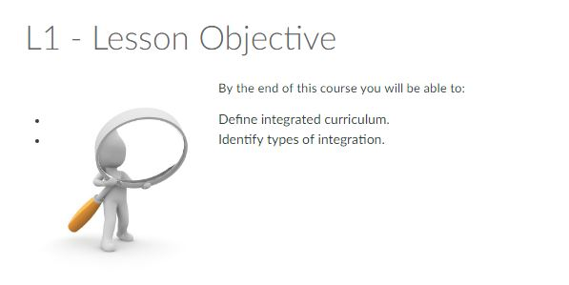

# **ISSUE #2: Topic 1: Definition of Multidisciplinary**

The text refers to the image as “the image below” when clearly, it’s next to it.

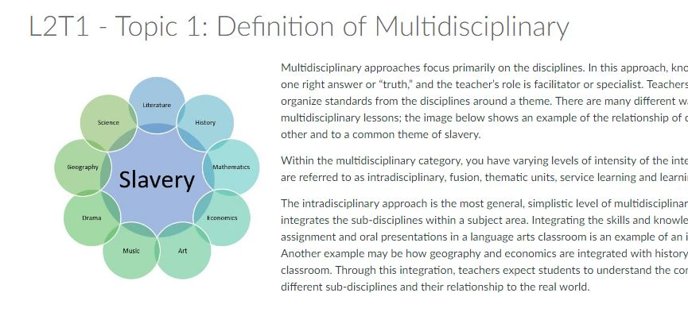

* **ISSUE #3: L5T1 - Topic 1: Planning**

The image is not clean enough. Steps are no visible.

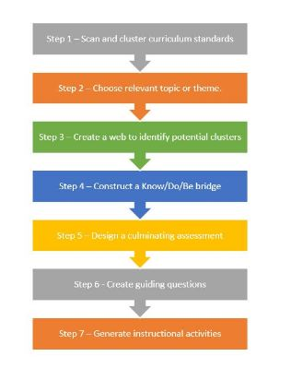

# **#ISSUE 4: L6T1 - Topic 1: Finding the Connections**

There’s no space between the image and the divisor line.

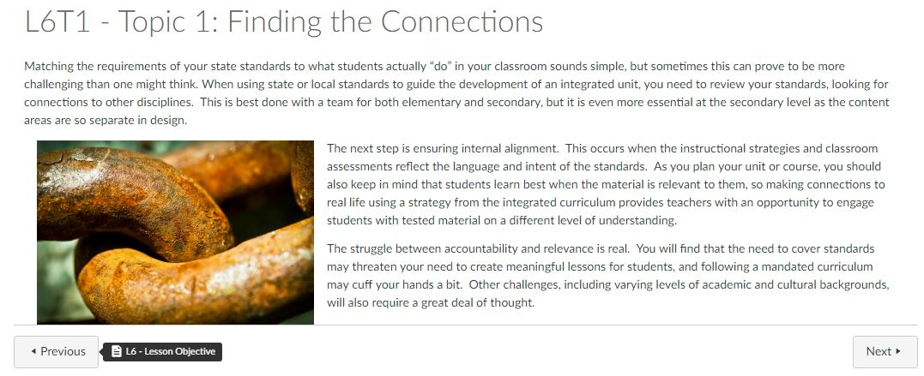

# **#ISSUE 5: L6T3**

When L6 is finished the “next” button redirects to final project. L7 and L8 are ignored and links in syllabus section of this lessons show a message of: This lesson hasn’t been unlocked.

